Database Design

# 1) CUSTOMER MANAGEMENT

## A screenshot of a computer Description automatically generated1.1. "Customer" Table

#### Purpose

Manages customer information like personal details, contact information, and registration date. Essential for identifying and contacting customers.

#### Data Validation

* **Primary Key Constraint:** (CustomerID) Ensures unique identification of each customer.
* **NOT NULL Constraints:** Prevent missing essential details like (FirstName) and (LastName).
* **CHECK Constraints:**
* Validates (FirstName) and (LastName) length.
* Ensures (Email) follows a valid format and is unique.
* Validates (PhoneNumber) starts with digits.
* Limits (PostalCode) length.

#### 1.1.3. Code & Output Results

# 2) EMPLOYEE MANAGEMENT

## 2.1. "Employee" Table

#### 2.1.1. Purpose

Maintains employee information, linking employees to roles. Tracks hire dates and contact details for the organization.

#### 2.1.2. Data Validation

* **Primary Key Constraint:** (EmployeeID) Uniquely identifies employees.
* **Foreign Key Constraint:** (RoleID) Links employees to roles.
* **NOT NULL Constraints:** Prevent missing essential details like (FirstName), (LastName), (Email) and (HireDate)
* **CHECK Constraints:**
* Validates (FirstName), (LastName), and (Email) format.
* Ensures (HireDate) is not in the future.

#### 2.1.3. Code & Output Results

## 2.2. "Role" Table

#### 2.2.1 Purpose

Defines roles (e.g. Admin, Manager) for employees, helping assign and manage responsibilities.

#### 2.2.2. Data Validation

* **Primary Key Constraint:** (RoleID) Ensures unique role identification.
* **NOT NULL Constraints:** Ensure (RoleName) is not empty.

#### 2.2.3. Code & Output Results

## 2.3. "AuditLog" Table

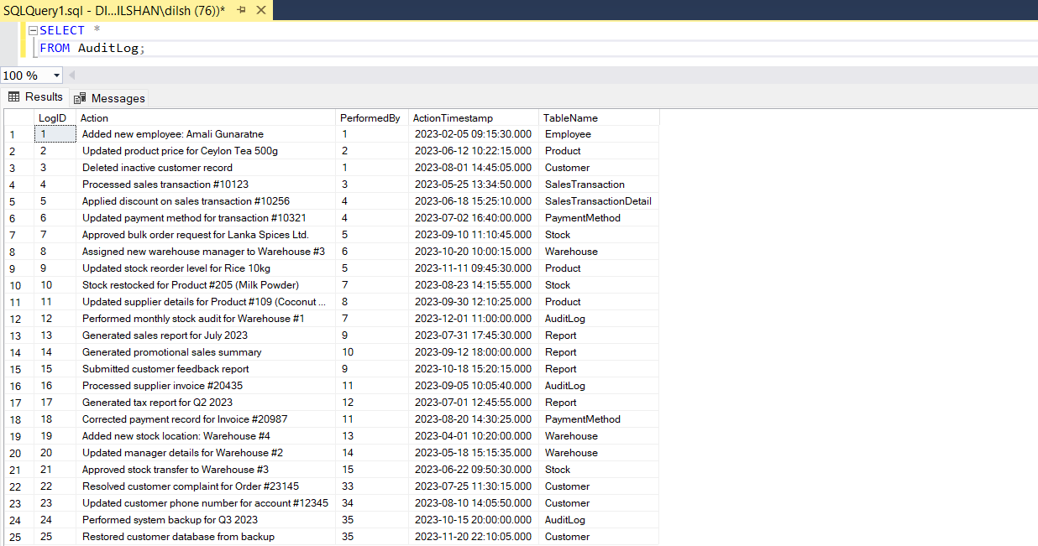

#### 2.3.1. Purpose

Logs administrative actions performed by employees, ensuring traceability and accountability.

#### 2.3.2. Data Validation

* **Primary Key Constraint:** (LogID) Unique identifier for log entries.
* **Foreign Key Constraint:** (PerformedBy) Links actions to employees, allowing NULL for unspecified actions.
* **NOT NULL Constraints:** Ensure (Action) and (ActionTimestamp) are not empty.

#### 2.3.3. Code & Output Results

# 3) REPORT GENERATION

## 3.1. "Report" Table

#### 3.1.1. Purpose

Stores generated reports, linking them to the responsible employee. Useful for record-keeping and analysis.

#### 3.1.2. Data Validation

* **Primary Key Constraint:** (ReportID) Uniquely identifies reports.
* **Foreign Key Constraint:** (GeneratedBy) Links reports to generating employees.
* **NOT NULL Constraints:** Prevent missing essential details (GeneratedDate) and (ReportType).
* **CHECK Constraints:**
* Ensures (ReportName) has at least 1 character

#### 3.1.3. Code & Output Results

# 4) PRODUCT AND STOCK MANAGEMENT

## 4.1. "Category" Table

#### 4.1.1. Purpose

Categorizes products for better organization and retrieval.

#### 4.1.2. Data Validation

* **Primary Key Constraint:** (CategoryID) Ensures unique category identification.
* **NOT NULL Constraints:** Ensure (CategoryName) is not empty.
* **CHECK Constraints:**
* Ensures (CategoryName) is unique and valid.

#### 4.1.3. Code & Output Results

## 4.2. "Brand" Table

#### 4.2.1. Purpose

Manages information about product brands, and helps in brand-based product searches.

#### 4.2.2. Data Validation

* **Primary Key Constraint:** (BrandID) Unique identifier for brands.
* **NOT NULL Constraints:** Ensure (BrandName) is not empty.
* **CHECK Constraints:**
* Ensures (BrandName) is unique and valid.

#### 4.2.3. Code & Output Results

## 4.3. "TaxRate" Table

#### 4.3.1. Purpose

Stores applicable tax rates for products, simplifying tax calculations.

#### 4.3.2. Data Validation

* **Primary Key Constraint:** (TaxRateID) Unique identifier for tax rates.
* **NOT NULL Constraints:** Ensure (TaxRate) is not empty.
* **CHECK Constraints:**
* Restricts (TaxRate) to a valid percentage (0-100).

#### 4.2.3. Code & Output Results

## 4.4. "Product" Table

#### 4.4.1. Purpose

Manages product information, including category, brand, pricing, and tax rates. Ensures active product status.

#### 4.4.2. Data Validation

* **Primary Key Constraint:** (ProductID) Ensures unique identification of products.
* **Foreign Key Constraints:** (CategoryID), (BrandID), (TaxRateID) Link products table to Category, Brand, and TaxRate tables.
* **NOT NULL Constraints:** Prevent missing essential details like (ProductName), (UnitPrice), (ReorderLevel) and (IsActive) status.
* **CHECK Constraints:**
* Ensure (ProductName) is valid.
* Validate (UnitPrice) and (ReorderLevel) are non-negative.

#### 4.4.3. Code & Output Results

## 4.5. "Warehouse" Table

#### 4.5.1. Purpose

Tracks warehouse details, including location and manager assignment.

#### 4.5.2. Data Validation

* **Primary Key Constraint:** (WarehouseID) Unique identifier for warehouses.
* **Foreign Key Constraint:** (ManagerID) Links managers to warehouses, allowing NULL.
* **NOT NULL Constraints:** Ensure (WarehouseName) is not empty.
* **CHECK Constraints:**
* Check (WarehouseName) is valid.

#### 4.5.3. Code & Output Results

## 4.6. "Stock" Table

#### 4.6.1. Purpose

Tracks product quantities available in warehouses and the last restocking date.

#### 4.6.2. Data Validation

* **Primary Key Constraint:** (StockID) Unique identifier for stock records.
* **Foreign Key Constraints:** (ProductID), (WarehouseID) Link stocks to Product and Warehouse.
* **NOT NULL Constraints:** Ensure (QuantityAvailable) is not empty.
* **CHECK Constraints:**
* Ensure (QuantityAvailable) is non-negative.
* Validate (LastRestockedDate) is not in the future.

#### 4.6.3. Code & Output Results

# 5) DISCOUNT MANAGEMENT

## 5.1. "Discount" Table

#### 5.1.1. Purpose

Manages discounts, ensuring valid date ranges and percentage constraints.

#### 5.1.2. Data Validation

* **Primary Key Constraint:** (DiscountID) Unique identifier for discounts.
* **NOT NULL Constraints:** Prevent missing essential details like (DiscountName), (DiscountType), (StartDate) and (EndDate).
* **CHECK Constraints:**
* Ensures (EndDate) is not before (StartDate).

#### 5.1.3. Code & Output Results

## 5.2. "ProductDiscount" Table

#### 5.2.1. Purpose

Maps products to specific discounts, enabling easy application of discounts.

#### 5.2.2. Data Validation

* **Primary Key Constraint:** (ProductDiscountID) Unique identifier for discount mappings.
* **Foreign Key Constraints:** (ProductID), (DiscountID) Link mappings to Product and Discount.

#### 5.2.3. Code & Output Results

# 6) SALES MANAGEMENT

## 6.1. "PaymentMethod" Table

#### 6.1.1. Purpose

Lists accepted payment methods, ensuring proper classification of transactions.

#### 6.1.2. Data Validation

* **Primary Key Constraint:** (PaymentMethodID) Unique identifier for payment methods.
* **NOT NULL Constraints:** Ensure (PaymentType) is not empty.
* **CHECK Constraints:**
* Check (PaymentType) is valid.

#### 6.1.3. Code & Output Results

## 6.2. "SalesTransaction" Table

#### 6.2.1. Purpose

Records sales transactions, including customer, payment method, and final amounts.

#### 6.2.2. Data Validation

* **Primary Key Constraint:** (TransactionID) Uniquely identifies transactions.
* **Foreign Key Constraints:** (CustomerID), (PaymentMethodID) Link transactions to Customer and PaymentMethod tables.
* **NOT NULL Constraints:** Prevent missing essential details (TransactionDate), (TotalAmount) and (FinalAmount).
* **CHECK Constraints:**
* Ensure (TotalAmount), (DiscountApplied), and (FinalAmount) are non-negative.

#### 6.2.3. Code & Output Results

## 6.3. "SalesTransactionDetail" Table

#### 6.3.1. Purpose

Break down each sales transaction into individual product-level details.

#### 6.3.2. Data Validation

* **Primary Key Constraint:** (TransactionDetailID) Unique identifier for transaction details.
* **Foreign Key Constraint:** (TransactionID), (ProductID) Link details to SalesTransaction and Product.
* **NOT NULL Constraints:** Ensure (Quantity), (UnitPrice) and (LineTotal) are not empty.
* **CHECK Constraints:**
* Ensure (Quantity), (UnitPrice), and (LineTotal) are positive values.

#### 6.3.3. Code & Output Results

Database Diagram

